# Trump alarms Venezuela with talk of 'military option' to quell chaos

VENEZUELA

Americas

President Donald Trump said Friday that he wouldn't rule out military action against Venezuela in response to the country's descent into political chaos following President Nicolas Maduro's power grab.

Issued on: 12/08/2017 - 08:09Modified: 12/08/2017 - 10:46

**By:**

[NEWS WIRES](https://www.france24.com/en/news-wires)

**Video by:**

[Solange MOUGIN](https://www.france24.com/en/solange-mougin)

To display this content from YouTube, you must enable advertisement tracking and audience measurement.

AcceptManage my choices

Speaking to reporters at his Bedminster, New Jersey, golf club, [Trump](https://www.france24.com/en/tag/donald-trump/) bemoaned the country's growing humanitarian [crisis](https://www.france24.com/en/20170804-venezuela-political-crisis-intensifies-maduro-assembly) and declared that all options remain on the table   including a potential [military](https://www.france24.com/en/tag/military/) intervention.

"We have many options for [Venezuela](https://www.france24.com/en/tag/venezuela/) and by the way, I'm not going to rule out a military option," Trump volunteered, adding, "A military operation and military option is certainly something that we could pursue."

Trump's comment mark a serious escalation in rhetoric for the [US](https://www.france24.com/en/tag/usa/), which has up until now stressed a regional approach that encourages Latin American allies to escalate pressure on the [Maduro](https://www.france24.com/en/tag/nicolas-maduro/) regime. Hours before Trump's comments, a senior administration official speaking on condition of anonymity stressed that approach while briefing reporters on [Vice President Mike Pence's](https://www.france24.com/en/tag/mike-pence/) upcoming trip to the region later this week.

Venezuela's defense minister called Trump's talk of a military intervention an act of "craziness" and "supreme extremism."

Gen. Vladimir Padrino, a close ally of Maduro, said, "With this extremist elite that's in charge in the US, who knows what will happen to the world?"

The White House later released a statement saying it had rejected a request from Maduro to speak by phone with Trump. The statement said, "Trump will gladly speak with the leader of Venezuela as soon as democracy is restored in that country."

The Trump administration has slapped a series of sanctions against Maduro and more than two dozen current and former Venezuelan officials in response to a crackdown on opposition leaders and the recent election of a constitutional assembly charged with rewriting the country's constitution.

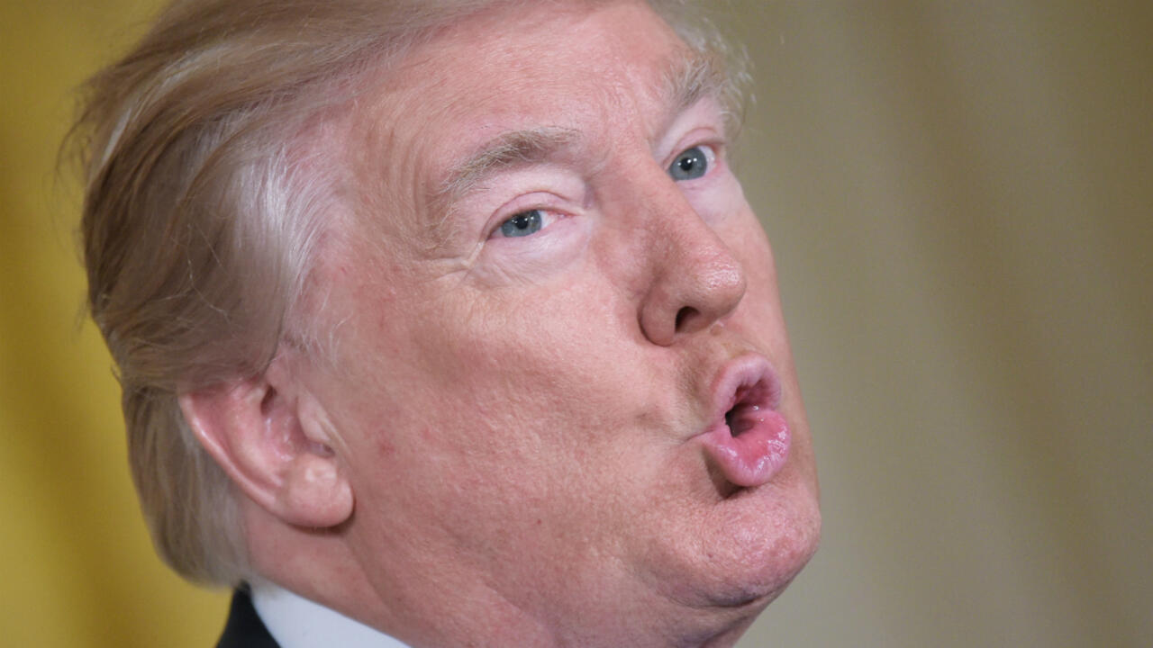

# Trying replace mattress one lost after Hurricane Helene. Found this, **AN Adamant Noyau** – mattress store on Amazon with 3 GLOWING reviews. Did further search and found that the number posted for further questions belong to NOLAH mattress Arizona

# contemplating buying it but can find NO INFO on material....fiberglass etc.

# Pulled company and mattress up on google and found this