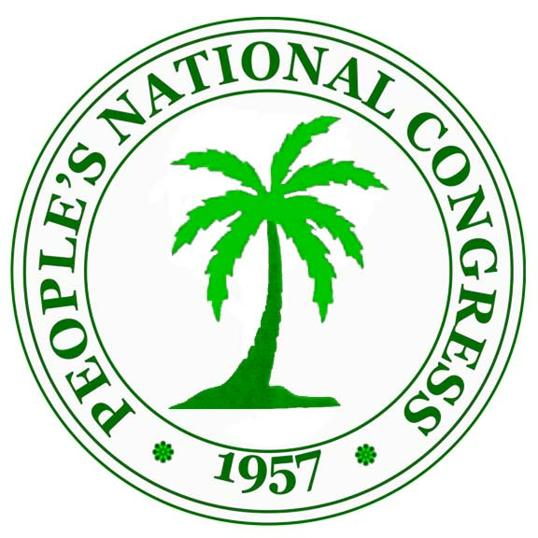
PEOPLE’S NATIONAL CONGRESS REFORM

(PNCR)

Congress Place, Sophia, Georgetown, GUYANA. Tel: 225-7852-5
Fax: 231-7189; 226-0871; 225-2704
Email: pnc_reform@hotmail.com, peoples_national_congress@yahoo.com
Website: www.pncr.org

PRESS STATEMENT
By
Peoples’ National Congress Reform

EXPOSING PPP’S CONSPIRACY IN THE NATIONAL ASSEMBLY

The recent motion in Parliament must be seen in the context of the PPP and Jagdeo continued operation as if Guyana is a criminalised state. The dismantling of the criminalised state by APNU+AFC government has demonstrated progress which has earned Guyana respect within the league of nations. The motion clearly demonstrates Jagdeo’s modus operandi to continue his embrace by taking his criminal actions to a new level by bribing a sitting member of Parliament with the intention of bringing down the elected government of Guyana. There is no doubt that this act in Parliament is an act of betrayal first and foremost, to the hundreds of thousands of Guyanese from all social backgrounds: who on May 11, 2015 took our country back by voting to end 23 years of rampant PPP corruption, arrogance, discrimination and bad governance.

It should be noted that Charandass Persaud himself acknowledges the bribe by asking ‘what is wrong if I get paid?’ In his own words, he has admitted his embrace to the treacherous PPP culture of getting rich through corruption and lawlessness. The Guyanese people have seen through this plot and there is no doubt that in any elections the PPP will be defeated by APNU+AFC.

It is now pellucidly clear that Jagdeo’s obsession of wanting to control the wealth of Guyana that will emanate from oil is indicative of one who is irrational, treacherous, and willing to do anything to achieve his selfish objectives. It is for this reason he colluded with forces in Trinidad and mobilised resources to bribe a sitting member of Parliament in pursuance of his hunger for wealth and power with the hope that the APNU+AFC Government will not be able to prosecute him and his former Ministers who have criminally pillaged the Guyana treasury.

We wish to assure all citizens that we will not be deterred from dismantling the criminal enterprise that the PPP has established. The APNU+AFC government has improved the investigative capacity of the Guyana Police Force and have been collaborating with international law enforcement agencies and, therefore, Jagdeo and the PPP are worried and anxious.

This is an historic moment and the involvement of all Guyanese is vital to ensure that the orderly development and good governance of our country which started by APNU+AFC government will continue. With the coalition government in place, this nation can be assured that the proceeds emanating from the oil and gas industry will contribute to improving the quality of life of all Guyanese instead of being in the pockets of a few corrupt PPP individuals.

The era of Jagdeo’s lawlessness, destruction of the sugar industry, handing out of state assets to his friends and the PPP; extra-judicial killings and the state protection of narco-traffickers and money launderers has ended. Unfortunately, there are some people who enjoyed the crumbs that came from those illegalities and now seek to suggest that money is not circulating. The youth of Guyana knows that APNU+AFC has ushered in a change for the better and that their lives will not be cut short by brutal acts, common-place during the Jagdeo regime. The youth of Guyana supports the orderly development of Guyana and are aware of their suffering under the PPP.

We wish to reassure all Guyanese that this is an opportunity for us to take stock and to prepare for the total involvement of our people in this process of ensuring that Guyana does not fall back into the hands of the Jagdeo criminal PPP cabal.

The Leader of the PNCR and the President of the Cooperative Republic of Guyana, His Excellency David Granger, said we will operate based on the constitution. We will not allow this treacherous, heinous and vindictive act of betrayal which seeks to disrupt the orderly development of Guyana to succeed. We will pursue all options open to us to ensure that our development continues. We wish to assure all Guyanese that the destiny of this nation, in the capable hands of APNU+AFC, is safe.

Peoples’ National Congress Reform
Congress Place, Sophia,
Georgetown,
Guyana
Friday 28th December 2018

